Book

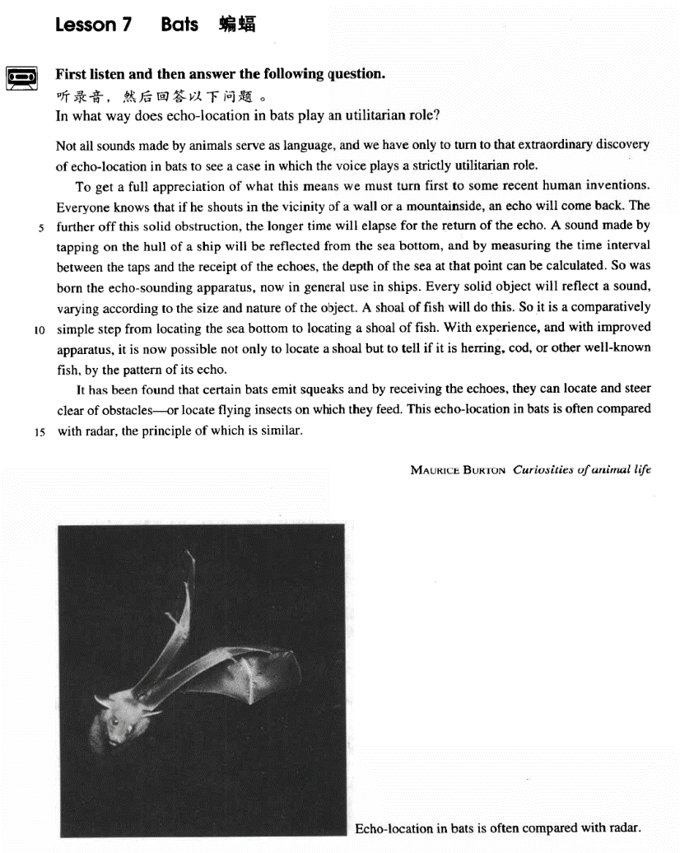

课文

Not all sounds made by animals serve as language, and we have only to turn to that extraordinary discovery of echo-location in bats to see a case in which the voice plays a strictly utilitarian role.

动物发出的声音不都是用作语言交际。我们只要看一看蝙蝠回声定位这一极不寻常的发现，就可以探究一下声音在什么情况下有绝对的实用价值。

To get a full appreciation of what this means we must turn first to some recent human inventions.

要透彻理解这句话的意义，我们应先回顾一下人类最近的几项发明。

Everyone knows that if he shouts in the vicinity of a wall or a mountainside, an echo will come back.

大家都知道，在墙壁或山腰附近发出的喊声，就会听到回声。

The further off this solid obstruction, the longer time will elapse for the return of the echo.

固体障碍物越远。回声返回所用时间就越长。

A sound made by tapping on the hull of a ship will be reflected from the sea bottom,

通过敲击空船发出的声音将会从海底反射回来。

and by measuring the time interval between the taps and the receipt of the echoes the depth of the sea at that point can be calculated.

测出回声间隔的时间，便可算出该处海洋的深度。

So was born the echo-sounding apparatus, now in general use in ships.

这样就产生了目前各种船舶上普遍应用的回声探测仪。

Every solid object will reflect a sound, varying according to the size and nature of the object.

任何固体者反射声音，反射的声音因物体的大小和性质的不同而不同。

A shoal of fish will do this.

鱼群也反射声音。

So it is a comparatively simple step from locating the sea bottom to locating a shoal of fish.

从测定海深到测定鱼群，这一进展比较容易。

With experience, and with improved apparatus, it is now possible not only to locate a shoal but to tell if it is herring, cod, or other well-known fish, by the pattern of its echo.

根据经验和改进了的仪器，不仅能够确定鱼群的位置，而且可以根据鱼群回声的特点分辨出是鲱鱼、鳕鱼，这是人们所熟悉的其他鱼。

It has been found that certain bats emit squeaks and by receiving the echoes,

人们发现，某些蝙蝠能发出尖叫声，并能通过回声

they can locate and steer clear of obstacles -- or locate flying insects on which they feed.

来确定并躲开障碍物，或找到它们赖以为生的昆虫。

This echo-location in bats is often compared with radar, the principle of which is similar.

蝙蝠这种回声定位常常可与雷达相比较，其原理是相似的。

词汇讲解

Lesson 7 Bats

utilitarian [7ju:tɪlɪ'teəriən] adj. 实用主义的utilitarian adj. designed to be useful rather than attractive ugly utilitarian buildings

utilitarian furniture

elapse [ɪ'læps] v. 时间流逝

Three years elapsed. go by / pass

Three years went by / passed.

“*lapse* ” = slide collapse

relapse relapse into bad habits

interval ['ɪntəvl] n.（两件事之间的）间隔时间interval between A and B

at … intervals

at weekly / 20 minute intervals The trains run at hourly intervals.

Indeed, it may well be that those work is their pleasure are those who most need the means of banishing it at intervals from their minds.

shoal [ʃəʊl] n. 鱼群

a school / shoal of fish

a flock of sheep / pigeons

a herd of cattle / deer / elephants

a drove of horses / cattle / sheep

a pack of wolves / tigers / lions

a swarm of flies / bees

a colony of ants / termites

squeak [skwi:k] v. & n. （发出）尖叫声，尖锐的声音

the squeak of a mouse

The door opened with a squeak.

screech the screech of tire

scream / shriek

The girls are screaming / shrieking with excitement.

Bats are interesting animals. They are famous for their echo-location ability. Echo-location in bats are often compared with radar.

科技英语的特点

1、倾向于将动词名词化。

2、倾向于更多地使用被动语态。

Not all sounds *made by animals* serve as language, and we *have only to*

turn to that extraordinary discovery of echo-location in bats *to* see a case in which the voice plays a strictly utilitarian role.

not 与全部肯定词 all, every, everything, everyone, both 连用，多表示

部分否定。

All that glitters is not gold. (Shakespeare: The Merchant of Venice) All of the arrows didn’t hit the target.

All civilized people can’t be cannibals.

Not all the water in rough rude sea can wash the balm off from an anointed king.

None of the arrows hit the target.

Not every sound made by animals serves as language. serve as… be used as…

act as… function as…

One of the most famous sailing ships of the nineteenth century, the Cutty Sark, can still be seen at Greenwich. She stands on dry land and is visited by thousands of people each year. She serves as an impressive reminder of the great ships of past.

have only to do … to do … 只须……就可以……

You have only to press the button to call the nurse.

You have only to click the following link to download the software.

have only to turn to sth. to do … 只需借助于……就可以……

造句：我们只需借助于 1936 年奥运会的具体例子就可以知道国际体育比赛会导致疯狂的仇恨。

We have only to turn to the concrete example of the 1936 Olympic Games to know that international sporting contests lead to orgies of hatred.

strictly adv. exactly and completely 完全地

She is strictly a beauty.

It’s strictly a neutral organization. play a …role / part in sth.

The river which forms the eastern boundary of our farm has always played an important part in our lives.

The government should play a more prominent part in promoting human rights. This applies particularly to chemical industries, where chance discoveries play a much larger part than they do in physical and mechanical industries. The fact of first-rate importance is the predominant role that custom plays in experience and in belief, and the very great varieties it may manifest.

John Dewey has said in all seriousness that the part played by custom in shaping the behavior of the individual, as against any way in which he can affect traditional custom, is as the proportion of the total vocabulary of his mother tongue against those words of his own baby talk that are

taken up into the vernacular of his family. To get a full appreciation of *what this means* we must turn first to some recent human inventions. There is a growing appreciation of the need for environmental reforms. There is, I think, much truth in Patricia Nelson Limerick’s observation

that “lecturing is an unnatural act, an act for which God did not design

human.” With the start of BBC World Service Television, millions of viewers in Asia and America can now watch the Corporation’s news coverage, as well as listen to it. Social science disciplines include

geography, economics, political science, psychology, and sociology.

“The test of any democratic society,” he wrote in a *Wall Street Journal* column, “lies not in how well it can control expression but in whether it gives freedom of thought and expression the widest possible latitude, however disputable or irritating the results may sometimes be.

… to fully appreciate what this means … resort to …

We can solve this problem without resorting to legal action.

Everyone knows that *if he shouts in the vicinity of a wall or a*

*mountainside*, an echo will come back. in the vicinity of …

in the neighborhood of …

close to … adjacent to … near … off …

I rent an apartment off campus.

She needs help finding a place to live.

There aren't enough rooms available in the dormitories.

She can't afford to live on campus.

She doesn't want to live in university housing.

M: Will you be living in the dormitory this year?

W: Not if I can help it. I've been thinking of renting an apartment off campus with some friends of mine.

Q: What does the woman imply?

Answer: (D) She doesn't want to live in university housing.

come back bounce back be reflected

A sound made by tapping on the hull of a ship will be reflected from the sea bottom, …

The further off this solid obstruction, the longer time will elapse for the

return of the echo.

He lives far away. = He lives far off.

the further off this solid obstruction is … further farther

further development / investigation

The time and the distance are in proportion.

A sound made by tapping on the hull of a ship will be reflected from the sea bottom, and *by measuring the time interval between the taps and the*

*receipt of the echoes*, the depth of the sea at that point can be calculated.

will be reflected = will come back = will bounce back sea bottom = sea bed = sea floor

… between the tapping and receiving the echoes … sb. can calculate sth.

sth. can be calculated sound will be reflected depth can be calculated

The echo-sounding apparatus was born so.

Every solid object will reflect a sound, varying according to the size and nature of the object.

vary according to sth.

造句：每一个退休工人都可以得到一笔退休金 (pension)，根据职务(post) 和工作年限 (working period) 而有所不同。

Every retired worker can receive a pension, varying according to his post and working period.

A shoal of fish will reflect a sound, varying according to its size and nature.

comparatively adv. relatively

It is a *comparatively simple step* from A to B. It is a *small step* from A to B.

That’s one *small step* for a man, one giant leap for mankind.

— Neil Armstrong It is a small step from loving a man to hating him.

It is a small step from loving a man to the bone to hating him to the core.

With experience, and with improved apparatus, it is now possible not

only to locate a shoal but to tell if it is herring, cod, or other well-known

fish*, by the pattern of its echo*.

with experience √

with accumulating experience X with time √

with passing time X

with seasons √

with changing seasons X

Vigorous writing is concise. A sentence should contain no unnecessary words, a paragraph no unnecessary sentences, for the same reason that a drawing should have no unnecessary lines and a machine no unnecessary parts.

— William Strunk, Jr.

the cause of justice √

the cause of national reunification X the cause of socialist construction X

accelerate the speed of economic reform X

The captain knew that his attempt would not be the only attempt. The captain knew that his attempt would not be the only one.

The captain knew that his would not be the only attempt.

Our age is a tragic age. Our age is a tragic one. Ours is a tragic age.

— Shakespeare

Brevity is beauty.

简洁即是美。

… to distinguish different species of fish … by prep. according to …

Even by modern standards, the 46,000 ton Titanic was a colossal ship.

It has been found that certain bats emit squeaks and *by receiving the*

*echoes,* they can locate and steer clear of obstacles—or locate flying insects on which they feed.

emit: “*e* ”(out) + “*mit* ”(send) transmit: “*trans* ” (across)+ “*mit* ” sexually transmitted diseases

The US open will be transmitted live via satellite. omit: “*o* ”=“*ob* ”(away) + “*mit* ”

submit: “*sub* ”(under) + “*mit* ”

vomit: “*vo* ”(eat) + “*mit* ”

steer clear of … = avoid … = get around … We tried to steer clear of political issues.

I steered clear of the main roads where I might be recognized.

feed on sth. Cows feed on hay. prey on sth. Owls prey on mice. live on sth.

This echo-location in bats is often compared with radar, the principle of which is similar.

compare A with / to B contrast A with B

“名词+介词+关系代词” 引导非限定性定语从句

造句：他有两个儿子，其中的一个死于战火。

He has two sons, one of whom died in the war.

造句：演讲者提了四个问题，它们的答案被证明非常有启发性。 The speaker posed four questions, the answers to which proved very illuminating.

The most valuable find of all was the ship's log book, parts of which it was still possible to read.